I. American Economic System as a Social Problem

A. Monopoly Capitalism

1. multi-national corporations

2. concentration of ownership

3. shared monopolies

4. interlocking directorates

5. “persons” within meaning of the law

6. legal obligation

B. Reasons

1. mergers

2. acquisitions

3. failure to regulate

4. deregulation

C. Power and Monopoly capitalism

1. power over economy

a. deindustrialization

b. r and d, prices

2 power over workers

3. power over communities

4. power over political system

D. Power over economy

1. downsizing

2. off shoring

a. GE

b. Wal-Mart

3. outsourcing

4. automation

E. Jobs: Service-based

1. four out of five: McJobs (50% created since “recovery”)

i. part-time

ii. low wage

iii. no benefits/too expensive

iv. no advancement

v. easily replaceable

vi. alienating

vii. emotional labor

2. Temps/contingent employment

i. +400 per cent since 1980s

ii. 40% less per hour

3. Internships

i. unpaid or low income

ii. no guarantee of job

4. Jobs lost (21% low income) and gained (58% low income)

F. Example: San Diego

1. 61% since 2001 less than $25,000

2. mainly in service sector

3. On average, all households lost $2,337 in purchasing power from 2010 to 2011

d. 136,000+ working full-time but w/o health care

G. Monopoly Capitalism and Corporate Profits

1. 2001 $503 billion 2008 $1.35 trillion

2. ALL TIME RECORD 2010 $1.68 TRILLION

3. Cash on hand $2 trillion (largest in over fifty years)

4. Fortune 500 2011 all time record $824 billion

5. Taxes

a. 60 % of companies pay no taxes

b. Corp contribution to federal tax revenue: 1950/30% to 2010 8%

c. GE $14.2 billion, $1.1 billion tax benefit

d. 2008-2010 12 lgst corps +$170 billion -1.5% tax rate

e. Deficit Commission recommendation: cut corporate taxes

H. Monopoly Capitalism and deindustrialization are structural reasons for increasing inequality

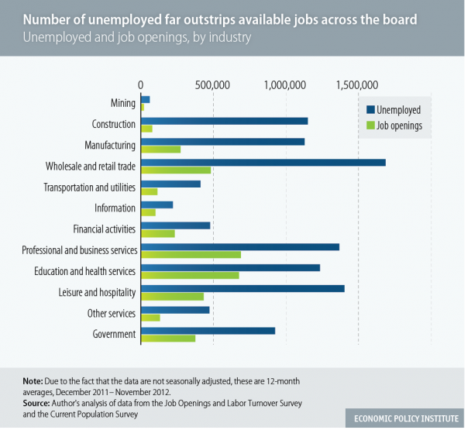

J. Laissez faire and “Wealthfare” Capitalism

1. $1 trillion (not country $20 trillion to save “Wall Street”)

2. R and D

a. $72 billion

b. Taxol

c. “clean coal”

3. Tax breaks, loopholes, havens

a. Cruise lines

b. GE 14.2 billion profit, 1.1 billion tax benefit

c. Work opportunity tax credit

4. subsidies: agriculture, nuclear industry

5. environmental and social costs to people

6. bailouts: “too big too fail”

- weapons and intelligence industries

8. physical, financial, civil and military infrastructruer

